how to guide/ idrac
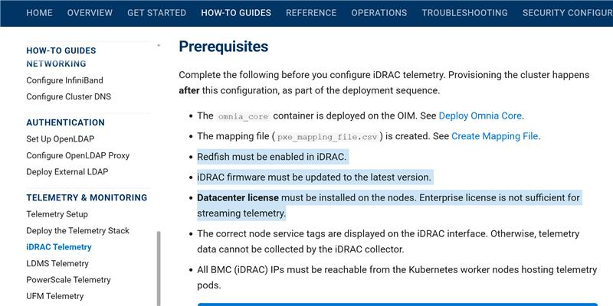
this prereq need to be added in 2.3 also
-------------
these needs to be remove from 2.3
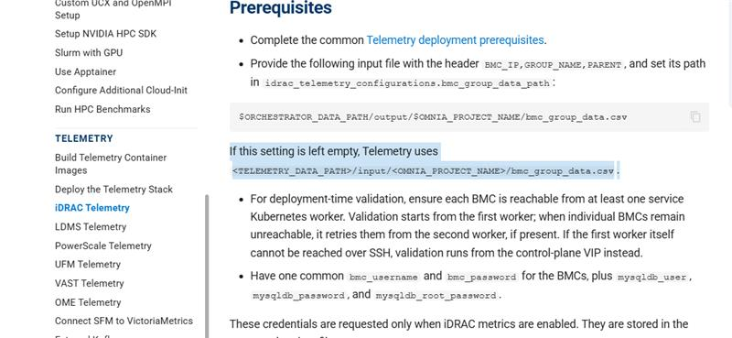
----
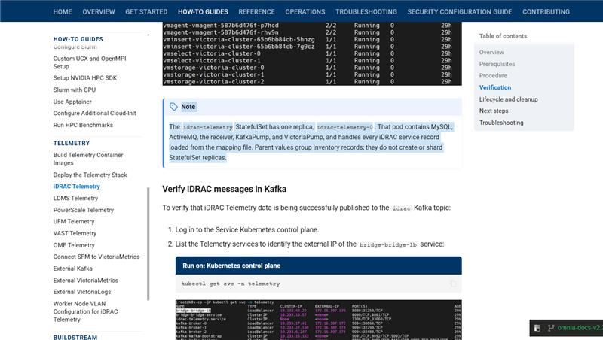
this note can be update like:

> Note: The idrac-telemetry StatefulSet is dynamically scaled based on bmc_group_data.csv. It creates one pod for MGMT_node (idrac-telemetry-0) and one
> additional pod for each unique, non-empty parent value. Each pod contains MySQL, ActiveMQ, the receiver, KafkaPump, and VictoriaPump. BMC records without
> a parent are assigned to the MGMT pod, while records belonging to each parent are assigned to that parent’s dedicated pod. For example, three parent
> groups create four pods: one MGMT pod and three parent pods.

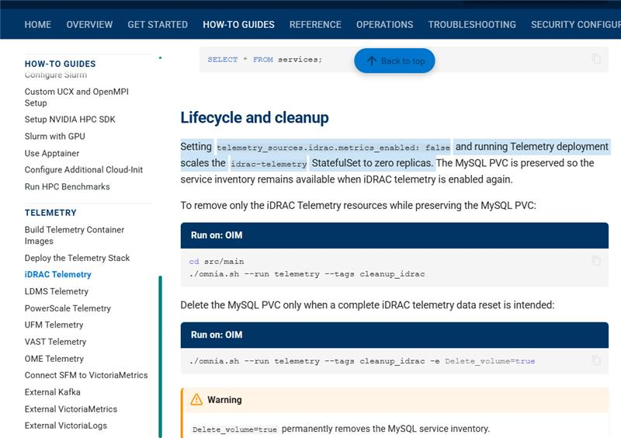
this point is not valid with src code now

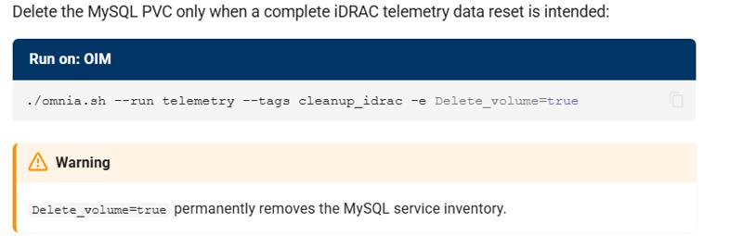
thes -e is wrong need to sunk with code, it was changed

OIM Cleanup - Omnia: Everything at once! We need to update the same here also Delete_volume is now changed to Delete_sinks_volume
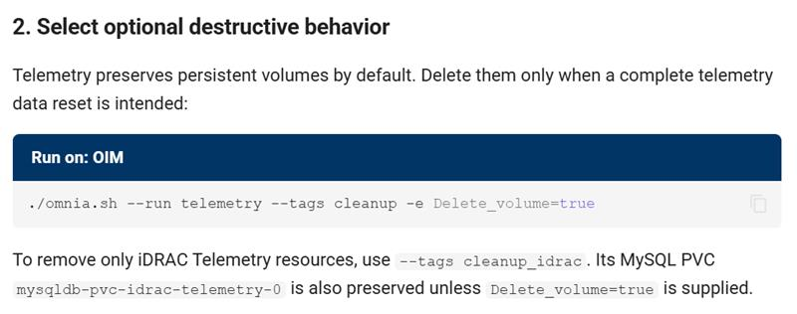
And need to remove component wise cleanup: "To remove only iDRAC Telemetry resources, use --tags cleanup_idrac. Its MySQL PVC mysqldb-pvc-idrac-telemetry-0 is also preserved unless Delete_volume=true is supplied." - This part from here
Deploy and manage HPC, AI, and data analytics clusters on Dell PowerEdge infrastructure

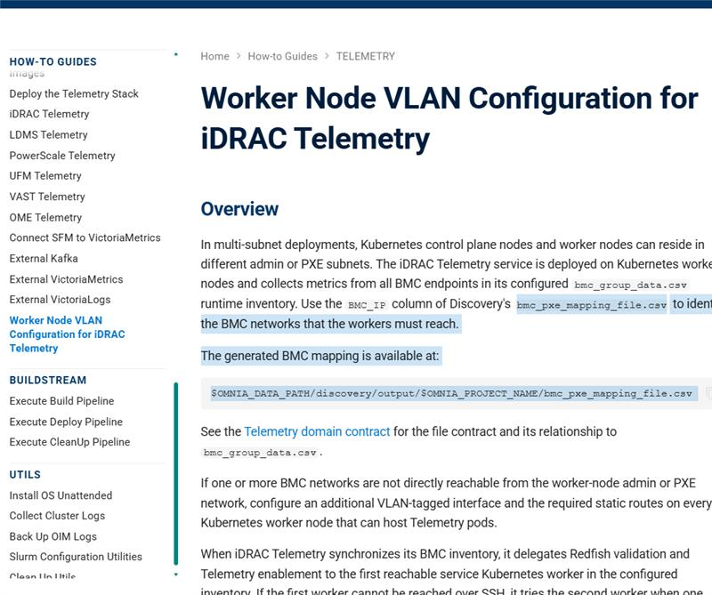
file name is wrong, rere idrac page for getting correct file name

------------
this variable link https://omnia-devel.readthedocs.io/en/v2.2.0.0/HowTo/Telemetry/worker_node_vlan_configuration_for_i… is missing in 2.3 , if any path need to make sure that is update with new paths of file

------------
can u please check this page is not updated Worker Node VLAN Configuration for iDRAC Telemetry - Omnia: Everything at once! with 2,2 part2 and part3, make sure that there is no direct reference for user to check pxe mapping file get alternative from AI based on code what user should check .

Deploy and manage HPC, AI, and data analytics clusters on Dell PowerEdge infrastructure

overview was asked to update same as 2.2 which not updated
https://omnia-devel.readthedocs.io/en/omnia-docs-v2.3.0.0/HowTo/Telemetry/configure_external_victor…

------------
need to be updated from here to the (2.3 -- point 3 to below till verififcation )
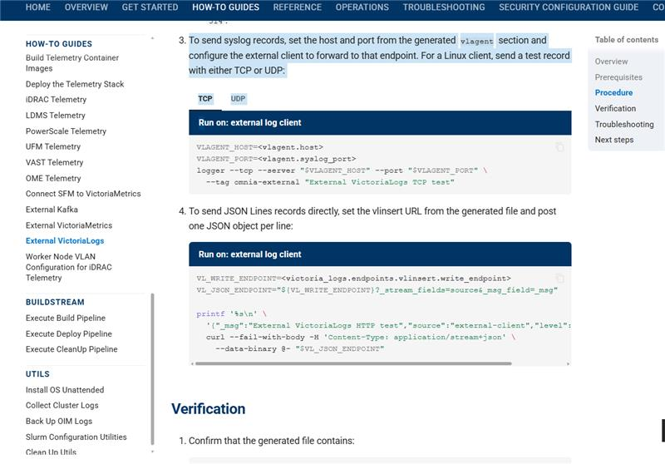
update with this: https://omnia-devel.readthedocs.io/en/v2.2.0.0/HowTo/Telemetry/configure_external_victoria_logs.htm… till verification
Deploy and manage HPC, AI, and data analytics clusters on Dell PowerEdge infrastructure

under this prunder this prerequisite can add these pints also:
- External access to VictoriaMetrics is available through:
  - LoadBalancer port 8480 for ingesting (inserting) data.
  - LoadBalancer port 8481 for querying data.
Deploy and manage HPC, AI, and data analytics clusters on Dell PowerEdge infrastructure

victroia metrics page:
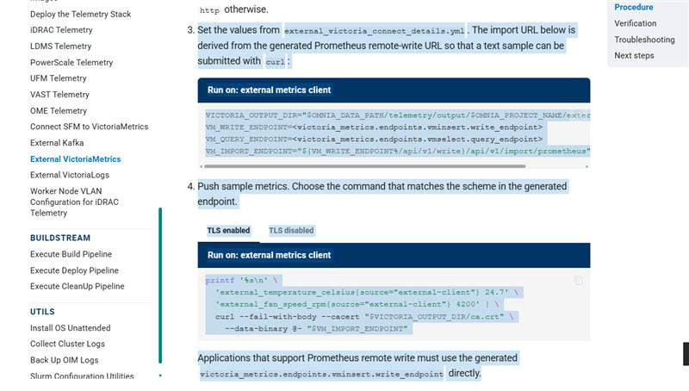
this info not require nor verification is correct, instead update from 2.2 doc (step-2 till complete versififcation) https://omnia-devel.readthedocs.io/en/v2.2.0.0/HowTo/Telemetry/configure_external_victoria.html#ste…
External VictoriaMetrics - Omnia: Everything at once!
Deploy and manage HPC, AI, and data analytics clusters on Dell PowerEdge infrastructure

opn page: External Kafka - Omnia: Everything at once!
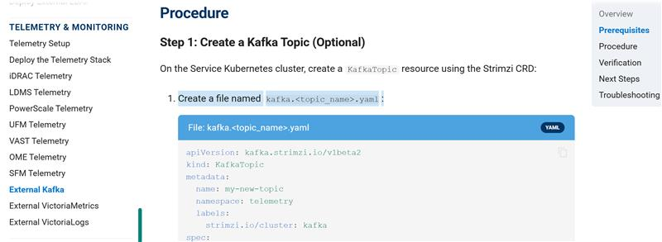
write this as optional , similar to how in 2.2
-------
these commands are changed from 2.2, copy same command
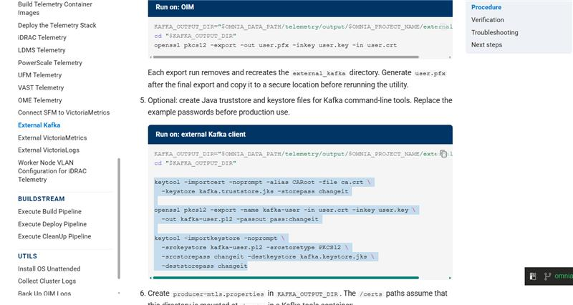
--------
here also commands are not exactly same as 2.2
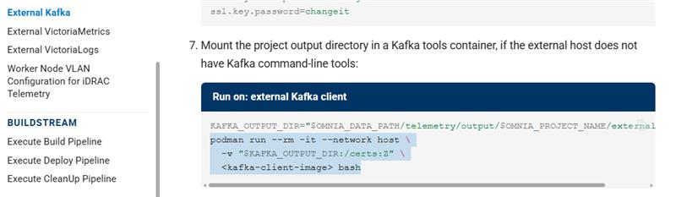
Deploy and manage HPC, AI, and data analytics clusters on Dell PowerEdge infrastructure

https://omnia-devel.readthedocs.io/en/omnia-docs-v2.3.0.0/HowTo/Telemetry/configure_external_kafka.…update this verififcation from 2.2
External Kafka - Omnia: Everything at once!
Deploy and manage HPC, AI, and data analytics clusters on Dell PowerEdge infrastructure

sfm page is completely missing from 2.2
Connect SFM to VictoriaMetrics - Omnia: Everything at once!
Connect SFM to VictoriaMetrics - Omnia: Everything at once!
Deploy and manage HPC, AI, and data analytics clusters on Dell PowerEdge infrastructure

ome:
on this page https://omnia-devel.readthedocs.io/en/v2.2.0.0/HowTo/Telemetry/telemetry_from_ome.html#verify-ome-m… from step4 - 7 update with this with given commands only copy commands to be updated

Run on: Kubernetes control plane

curl -ksS -X POST "https://$KAFKA_LB_IP:8080/consumers/$GROUP" \
-H 'content-type: application/vnd.kafka.v2+json' \
-d '{
"name": "ome-consumer",
"format": "json",
"auto.offset.reset": "earliest"
}'

View the configured OME Kafka topics:

Run on: Kubernetes control plane

curl -ksS -X GET "https://$KAFKA_LB_IP:8080/topics" \
-H 'accept: application/vnd.kafka.v2+json' | jq '.'

Subscribe the consumer to the selected topic:

Run on: Kubernetes control plane

curl -ksS -X POST \
"https://$KAFKA_LB_IP:8080/consumers/$GROUP/instances/$INSTANCE/subscription" \
-H 'content-type: application/vnd.kafka.v2+json' \
-d "{\"topics\": [\"$TOPIC\"]}"

Consume messages from the topic:

Run on: Kubernetes control plane

while true; do
curl -ksS -X GET \
"https://$KAFKA_LB_IP:8080/consumers/$GROUP/instances/$INSTANCE/records" \
-H 'accept: application/vnd.kafka.json.v2+json' | jq '.'
sleep 2
done

Optionally, delete the consumer after verification:

Run on: Kubernetes control plane

curl -ksS -X DELETE \
"https://$KAFKA_LB_IP:8080/consumers/$GROUP/instances/$INSTANCE"

--------------
https://omnia.readthedocs.io/en/v2.3.0.0-rc1/HowTo/Telemetry/telemetry_from_ome.html#view-ome-metri…
point1 can be replces with :
- Access the VMUI in a web browser:
https://<external vmselect loadbalancer IP>:8481/select/0/vmui
Deploy and manage HPC, AI, and data analytics clusters on Dell PowerEdge infrastructure

https://omnia-devel.readthedocs.io/en/v2.2.0.0/HowTo/Telemetry/telemetry_from_ome.html#view-ome-log…
update this point1 with
- Access the VictoriaLogs UI in a web browser:
https://<external vlselect loadbalancer IP>:9471/select/vmui
Deploy and manage HPC, AI, and data analytics clusters on Dell PowerEdge infrastructure

form this step3 and step4 https://omnia-devel.readthedocs.io/en/v2.2.0.0/HowTo/Telemetry/configure_vast.html#step-3-configure… it is missing in 2.3 doc
-----------
remove this
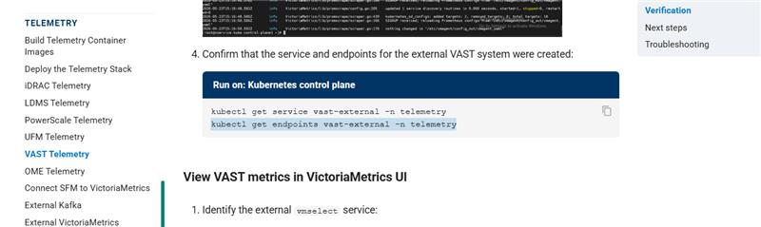
------------
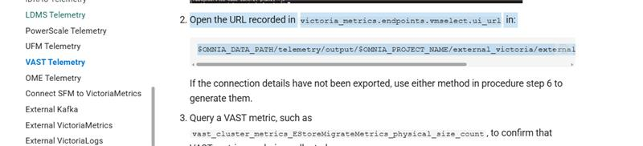
update this point with
Access the VMUI in a web browser:
https://<external vmselect loadbalancer IP>:8481/select/0/vmui
Deploy and manage HPC, AI, and data analytics clusters on Dell PowerEdge infrastructure

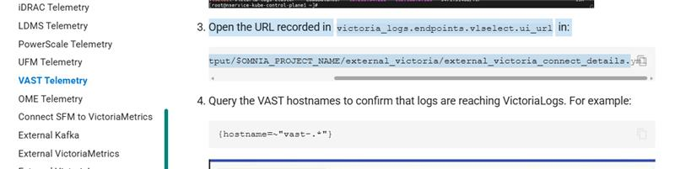
update point 3 with
Access the VictoriaLogs UI in a web browser:
https://<external vlselect loadbalancer IP>:9471/select/vmui

on this page: https://omnia.readthedocs.io/en/v2.3.0.0-rc1/HowTo/Telemetry/configure_ldms.html#verify-ldms-messag… (from step3-7)
update with commands given below

Create a Kafka consumer:

Run on: Kubernetes control plane

curl -ksS -X POST "https://$KAFKA_LB_IP:8080/consumers/$GROUP" \
-H 'content-type: application/vnd.kafka.v2+json' \
-d '{
"name": "ldms-consumer-1",
"format": "json",
"auto.offset.reset": "latest",
"enable.auto.commit": true
}'

View the list of configured LDMS Kafka topics:

Run on: Kubernetes control plane

curl -ksS -X GET "https://$KAFKA_LB_IP:8080/topics" \
-H 'accept: application/vnd.kafka.v2+json' | jq '.'

Subscribe the consumer to the LDMS topic:

Run on: Kubernetes control plane

curl -ksS -X POST \
"https://$KAFKA_LB_IP:8080/consumers/$GROUP/instances/$INSTANCE/subscription" \
-H 'content-type: application/vnd.kafka.v2+json' \
-d "{\"topics\": [\"$TOPIC\"]}"

Consume messages from the topic:

Run on: Kubernetes control plane

while true; do
curl -ksS -X GET \
"https://$KAFKA_LB_IP:8080/consumers/$GROUP/instances/$INSTANCE/records" \
-H 'accept: application/vnd.kafka.json.v2+json' | jq '.'
sleep 2
done
Deploy and manage HPC, AI, and data analytics clusters on Dell PowerEdge infrastructure

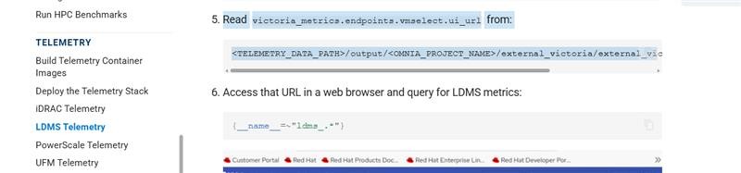
update up this with :
- Access the VMUI in a web browser:
https://<external vmselect loadbalancer IP>:8481/select/0/vmui

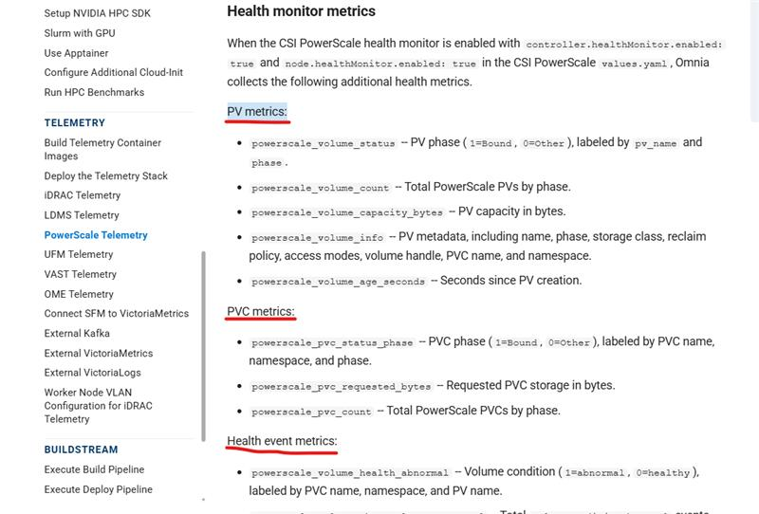
can we make all such as bold under this heading : Health Monitor Metrics¶
like how it is in 2.2

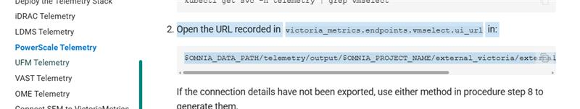
update this with:

- Access the VMUI in a web browser:
https://<external vmselect loadbalancer IP>:8481/select/0/vmui

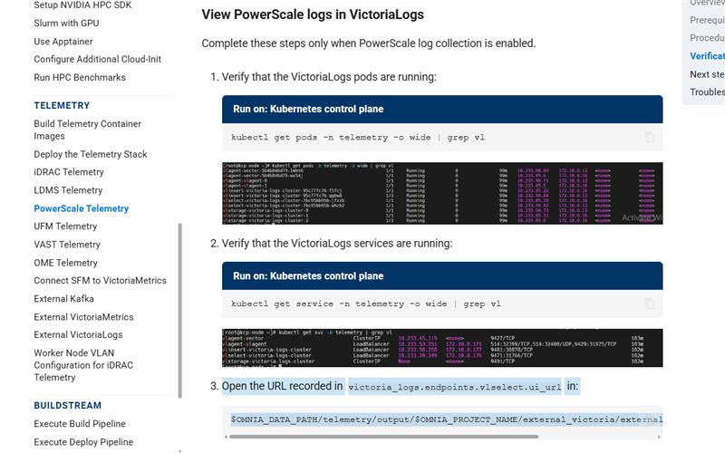
update this with:
- Access the VictoriaLogs UI in a web browser:
https://<external vlselect loadbalancer IP>:9471/select/vmui

Deploy and manage HPC, AI, and data analytics clusters on Dell PowerEdge infrastructure

https://omnia.readthedocs.io/en/v2.3.0.0-rc1/HowTo/Telemetry/configure_ufm.html#prerequisites
under this add points:

- Ensure the service Kubernetes cluster has sufficient resources to run vmagent (shared instance) and VLAgent.
- Network connectivity between the service Kubernetes cluster and the NVIDIA UFM appliance.
- A running NVIDIA UFM appliance (Omnia does not deploy UFM itself).
- Ensure that telemetry_config.yml has UFM telemetry entries enabled. For details on configuring telemetry_config.yml, see the telemetry configuration reference.
- UFM telemetry must bind and listen on a specific designated IP address rather than the default localhost (127.0.0.1).
- The following ports must be allowed through the firewalld service on the UFM appliance: 9000, 9001, and 9002. Ensure the necessary firewall rules are created and enabled before deployment.
- UFM must be deployed with self-signed SSL/TLS certificates and configured to listen on a specific IP address and designated port for secure communication.
https://omnia.readthedocs.io/en/v2.3.0.0-rc1/HowTo/Telemetry/configure_ufm.html#procedure
here before step1
from 2.2 step3 and 4 should come
https://omnia-devel.readthedocs.io/en/v2.2.0.0/HowTo/Telemetry/configure_ufm.html#step-3-configure-…
https://omnia-devel.readthedocs.io/en/v2.2.0.0/HowTo/Telemetry/configure_ufm.html#step-4-configure-…
step 6 not required
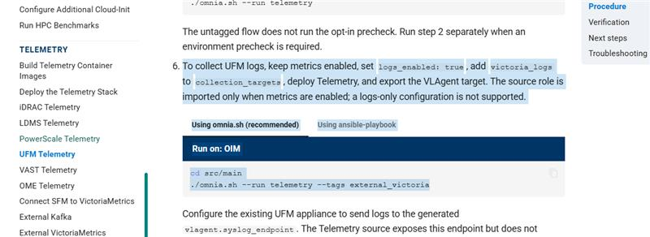
--------
not required
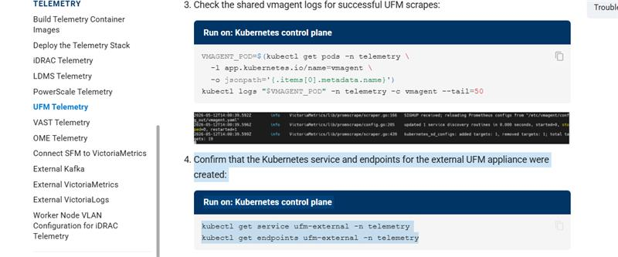

UFM Telemetry - Omnia: Everything at once!
Deploy and manage HPC, AI, and data analytics clusters on Dell PowerEdge infrastructure

can u please for these page what all updates were given before: Deploy the Telemetry Stack - Omnia: Everything at once! i dont see any much here
U might have note
i remember we decided to remove this playbook execution to add here
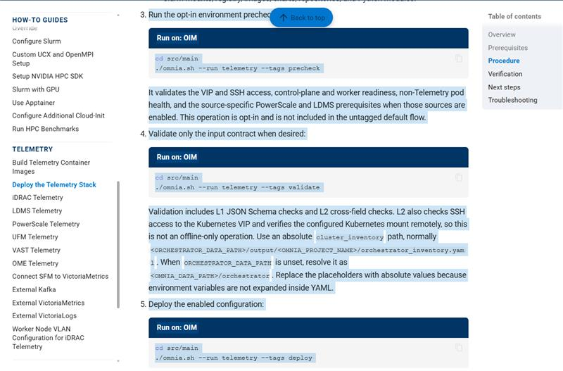

please check and update this aslo
Deploy and manage HPC, AI, and data analytics clusters on Dell PowerEdge infrastructure

Louis, Roselin we dont need this much details in document
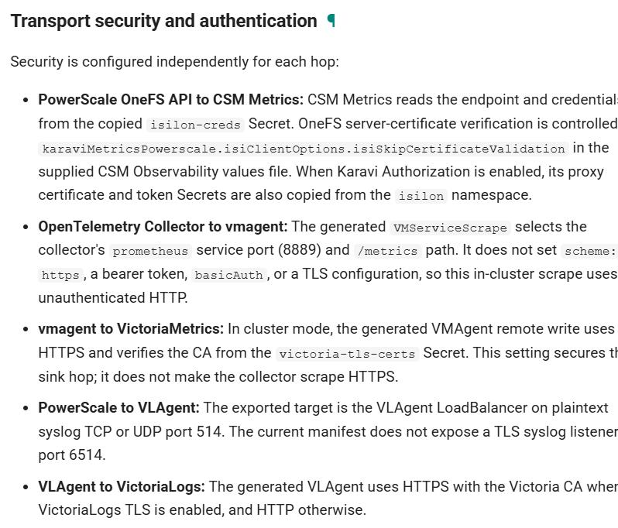
you can update as per 2.2
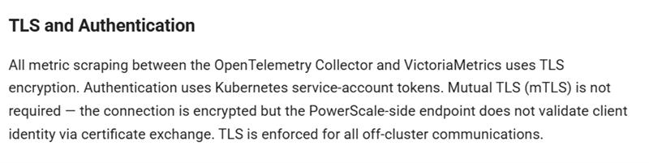

there is no change in internal fucntinality

